**Introduction**

The main goal of LinkUp is to allow travellers to find like-minded people wherever they go, to let tourists make new friends along their journeys and see local attractions and hidden gems of places with locals’ eyes, prioritising safe adventures over generic tour group experiences.

LinkUp is:

* For people looking to meet others while visiting or travelling to places that all participating parties have a mutual interest in
* For anyone looking to get to know a new group of friends in an area
* For those in need of companions with the same destinations and passions

**Purpose**

This section describes the capability available to our target audience:

* Groups can be created, edited, removed or promoted, based on the user role
* Users can create events and provide updates, locations, and other information such as fees, group capacity, and other info.
* Events can be created by both locals and tourists
* All users’ personal data is protected at all times

**Scope**

What LinkUp will do:

* Provide clean and intuitive interface, easy group creation or bookmarking tools
* Badges for local guides, so travellers can easily identify trusted guides from their new users
* Cross-compatibility and support for all major web-browsers

What LinkUp will not do (yet):

* Provide location-based alerts and suggestions
* Event promotion engine
* Content moderation of outside links and resources
* Mobile version of the application

**System Overview**

LinkUp as a system will involve two major user types: local guides and tourists. Travellers’ goals are simply using the system to view, join, or even create events, post messages, update their profiles and post messages to their ‘walls’, upload pictures and basic bio, sort events based on location (currently, we are only able to do that based on info users save in their profile, not based on their GPS coordinates). Local guides will have an ability to create events as well, provide excursions and guided tours. Tourists will also be able to create groups designed to attract fellow travellers based on their city/country of origin, to make exploration easier and more inclusive. Guides will have ‘trusted’ badges, as will the travellers, although this might be changed to a 5-star system or something similar.

**Project perspective**

Our system represents a social network that is revolving around tourism and hospitality, providing features that are not available on single platform, but on different web-based or mobile apps that have more narrow focus and functionality. LinkUp can be viewed both as an extension of current tools travellers use (e.g. AirBnB, CouchSurfer and certain other tools or social media) and a new self-contained system. In context of LinkUp being an extension of current services, its purpose is to fill in the gaps in missing functionality, complexity of, and number of services students have to use on daily basis. Its main purpose is to provide tourists and guides with a single network that provides the combined services of apps like Messenger and social media, with added functionality that other services like AirBnB or similar system lack.

**General Constrains**

While working on this project, we are presented with a number of constrains, main being: time, quality, security, and low adoption of the application. Time, quality/security and scope are interrelated, as a strain on one of these constrains puts pressure on two other risks. In relation to implementation of the system, same constrains stand but our main focus will be on the three biggest issues we are prepared to deal with.

* Time: our project deadline is April 2020, which not only gives us limited time to roll out the application, but also ties in with our other major risk: low adoption of the application. This does not work in our favour as we are presented with numerous new technologies we have to master in order to complete the project.
* Security: ties in with design and quality. One of LinkUp’s goals is to provide users with a simple and intuitive interface that lets them enjoy their travels or vacations while enhancing their experiences and immersing them in local culture. In relation to security, it’s important to keep users’ personal information safe, just as important as it is for administrators to keep LinkUp a safe and encouraging environment and to promote positive behaviours. As for quality, our main goal is to make the system a robust and reliable piece of software, so users can use it not only as a social tool, but also to plan ahead their days and use free time for something useful, like attending local small-scale events or simply exploring on their own with the help of LinkUp’s online resources or links posted by other users on group or personal ‘walls’.

**Assumptions and Dependencies**

* The app is always accurate and timely updated
* LinkUp’s Project Plan may change as new information and issues are revealed
* All the project’s team members will respect the rules set by the team leader
* Failure to adapt to changes in adequate time will lead to project delays

Our biggest challenges are reaching the target audience, main reason for that being our lack of past experience in IT and saturation of the market in relation to different social media tools being available. The project also makes assumptions listed above that may delay the release, or slow down the adoption of the application. In terms of inner workings of our group, we are facing not only the pressure of adhering to the communication plan, scheduling weekly/bi-weekly and monthly meetings, but also outside responsibilities of our personal and student lives. As our goal is to make other travellers lives easier, successful completion of the project will also help us in achieving the goal of becoming better students and higher skilled professionals when the time comes to find jobs in IT field.

**Functionality Requirements**

Registration:

* Tourists, local guides and pretty much anyone else can register using their email and a password
* Inputs: first and last name, home city, destination, handle, password, interests
* Processing: registration of a new user, creation of personal page, badge assignment to trusted users
* Outputs: personal page

Creating groups:

* Locals and travellers can create groups
* Inputs: name of the group, short description
* Processing: static page with group description and list of members
* Outputs: message board, links

Creating a post:

* Users are able to post question from or on their profile
* Inputs: question
* Processing: creation of the post on an appropriate event/personal page
* Outputs: post itself

Content moderation:

* System administrators are able to remove sensitive content, close events, or suspend user accounts
* Inputs: account type, report in regards to what and why is being deleted
* Processing: content moderation based on keywords (optional)
* Outputs: internal reports

**Challenges**

One of the challenges we have already faced is implementation, with regard to technologies available and used in development. Previously, we have planned to develop LinkUp using Angular and MongoDB, and now we’re switching to React and Firebase to allow smoother experience and help us complete the project on time. We had to remove certain functionality, such as location-based alerts and suggestions due to complexity and learning curve caused by complex Google Maps API’s and switch to a web-based application instead of developing mobile apps for iOS and Android.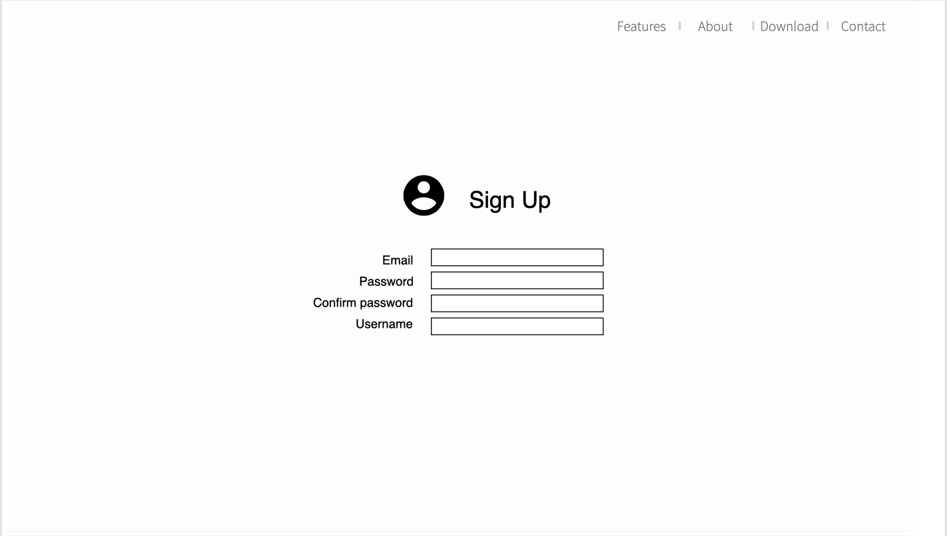

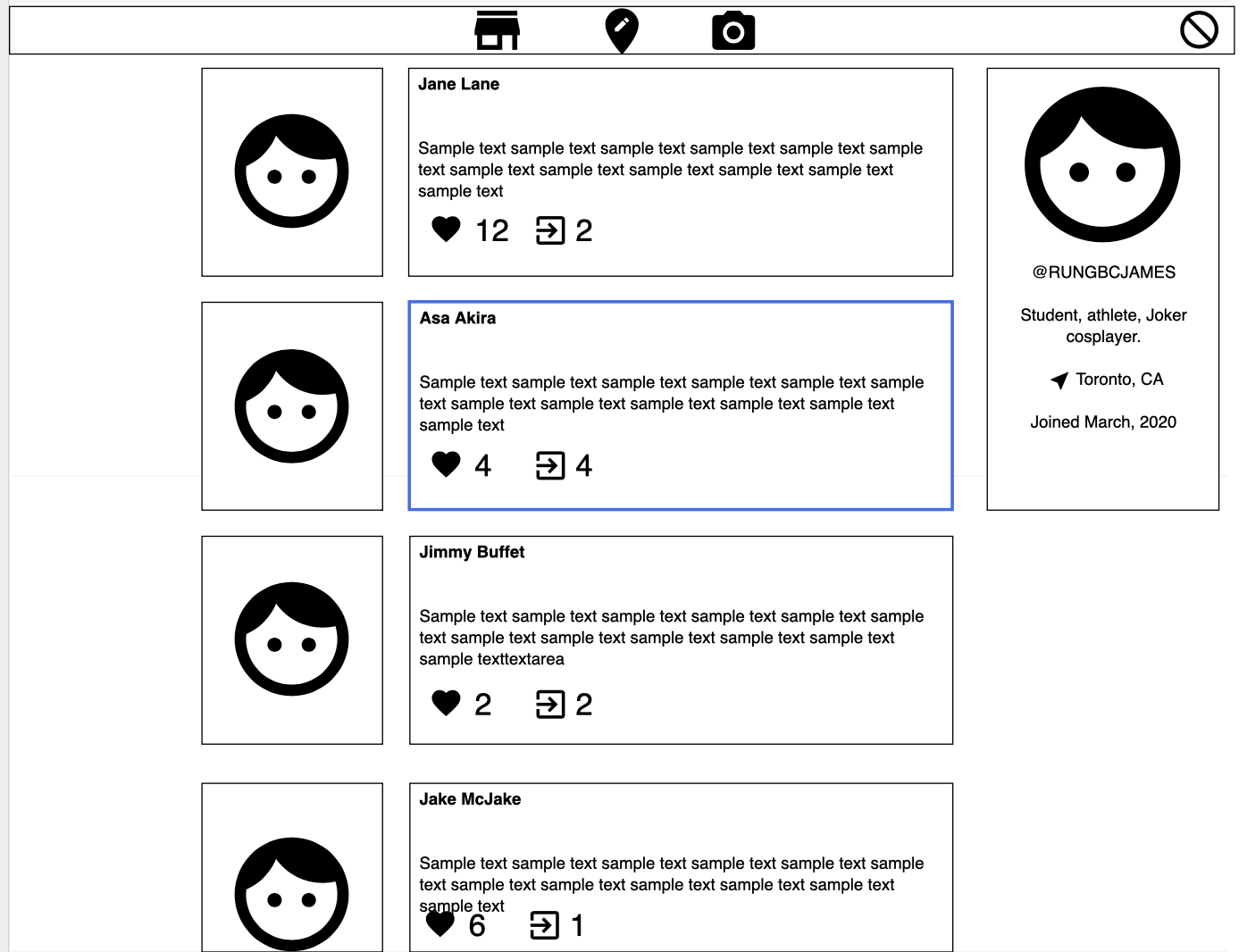

This is a sample interface we have come up with so far, due to time constrains we are working on the code ahead of the design, as all of our members have a general idea of what it is supposed to look like and time contains that make us prioritize code over design. To make this work for LinkUp, we are going to add list of groups the user has joined on the right panel under their bio, add destination city to their bio (which can be edited anytime), and allow group messages to be displayed on their ‘wall’, as long as the user seeing the message has joined that group and hasn’t muted it. As always, design is subject to change, but we prioritize clean and user-friendly interface over crowded screens and distracting ads.

Information linked below was taken from Sprint 4:

Technologies used for building our application

| Database | MongoDB |
| --- | --- |
| Programming Languages | HTML/CSS, JavaScript, Typescript, Java |
| Version Control | Git and GitHub |
| Third party technologies | Google Maps, Socket IO, AWS, NodeJS, Cordova/PhoneGap, JqueryMobile |
| Hardware | Personal Computers |

Note that currently we are using React as the framework to design our web application and Firebase as the database.

Reasons for using these technologies

We are using web technologies as they are more portable, by using a packager like PhoneGap we can port and install our app on many different platforms helping us bridge the gap between web and mobile platforms.

-HTML5/CSS

We are all familiar with HTML and CSS, making them an easy choice. They are used for virtually every website and can be viewed on basically any device.

We have a solid understanding and decent experience using these technologies which will in turn make the development process easier and more efficient.

-Google Maps API

We decided to use google maps API as it is the most popular geolocation service with a huge database for locations and landmarks and has a high number of resources which make it highly functional and reliable.

-Socket IO

Socket IO will be used for our chats, as it enables real-time bidirectional event-based communication, it’s very flexible as it works on every platform, browser or device, it is reliable and fast.

-JavaScript

We all have good amount of experience using JavaScript, and will be used to make our application dynamic and enriching the overall experience of the user, we might also use JavaScript frameworks that are currently not listed here

-NodeJS

It adds a ton of tools and possibilities to JavaScript and it’s frameworks.

-Java

We are using Java as it is one of the languages where most of us have experience with and will be used for the developing of the app in android if we ever choose to implement a native solution. We might also use it for server-side logic and backend in general.

-AWS

Amazon web services will provides us with a lot of options for scalability, and would help us escalate easily whenever we feel it’s necessary

-Git

Git will be used so everyone can work better developing the app, ensuring coordination across our team, we can easily keep track of changes made to our source code and experiment with new features without interfering or putting source code at risk.

-Github

We chose GitHub because is one of the largest coding communities and we all have experience working with it. This is our platform of choice for hosting our repository as they offer a good, easily implementable service for free.

Git, AWS, Github are still being used, in addition to Postman (testing), React (back end development) and Firebase (database).

Firebase - The **Firebase** Realtime **Database** is a cloud-hosted NoSQL **database** that lets us store and sync data between users in real time.

React – Javascript framework, can be used as a base to develop mobile versions of web applications

Learning plan

Our learning plan for this project will be mainly focused on AWS, NodeJS, Cordova, JQuery Mobile and Socket IO as these are the technologies we don’t have any experience with.

We have all come to the consensus that 3 weeks will be more than necessary to learn the technologies that will be needed for the development of our project

| Member | Technology to learn | Resources | Startdate | End date |
| --- | --- | --- | --- | --- |
| Esteban | AWS | AWS-Educate | December-15th | January 5th |
| Alejandro | Socket IO | <https://socket.io/get-started/chat/>  <https://socket.io/docs/client-api/> | December-17th | January 7th |
| Serhii | NodeJS | <https://nodejs.org/en/about/> | December-15th | January 5th |
| ALL | Cordova, jQuery Mobile | <https://jquerymobile.com/resources/>  <https://cordova.apache.org/docs/en/latest/guide/overview/> | December-15th | January 5th |